**INTRODUCTION TO C**

**C is a**

1. **It is a high level / middle level programming language.**
2. **C is a compiler based programming language.**
3. **C is a procedure oriented programming language[POP’s].**
4. **C is a general purpose programming language.**

**What is a program?**

**Set of instructions is called program.**

**What is a software?**

**Set of programs is called software. As per it industry software is a digitalized and automated process.**

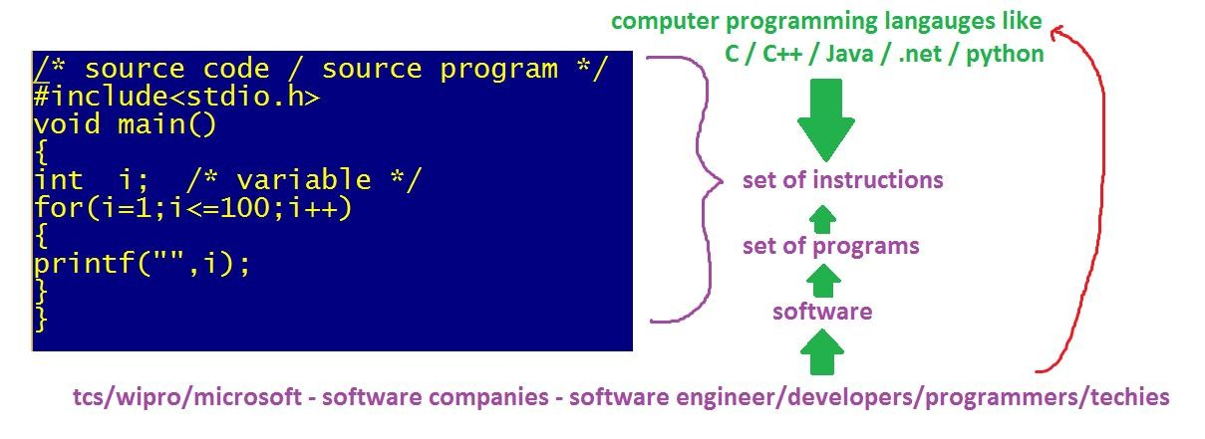

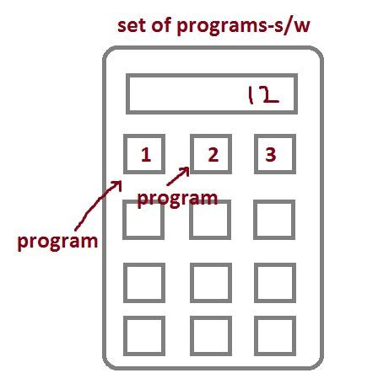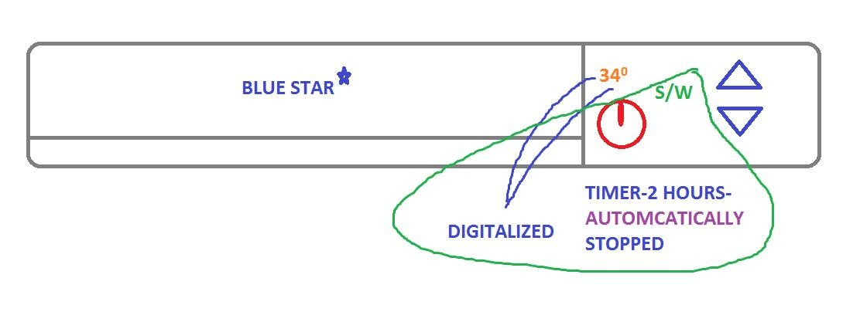

**We are having 2 type of software.**

1. **System software**

**Eg: o.s, device drivers, translators**

1. **Application software**

**Eg: phonepe, irctc, whatsapp,instagram,…**

**What is a language?**

**Generally the languages like telugu / English / Marathi / hindi etc are used to communicate with humans. Hence they are called human languages / regional languages. By using these human languages we can’t communicate with the machines. Hence we are using the computer programming languages like C / C++ / Java / .net / pythos etc. By using these languages we are creating the software [ programs ] to communicate.**

**Basically the languages are divided into 3 types.**

1. **Machine language: Created with binary code [0,1] and very difficult to understand. Eg: 1000111**
2. **Low level / assembly language: Created with English like shortcuts called MNEMONICS.**

**Eg: gd mrg, plz, sub,…….**

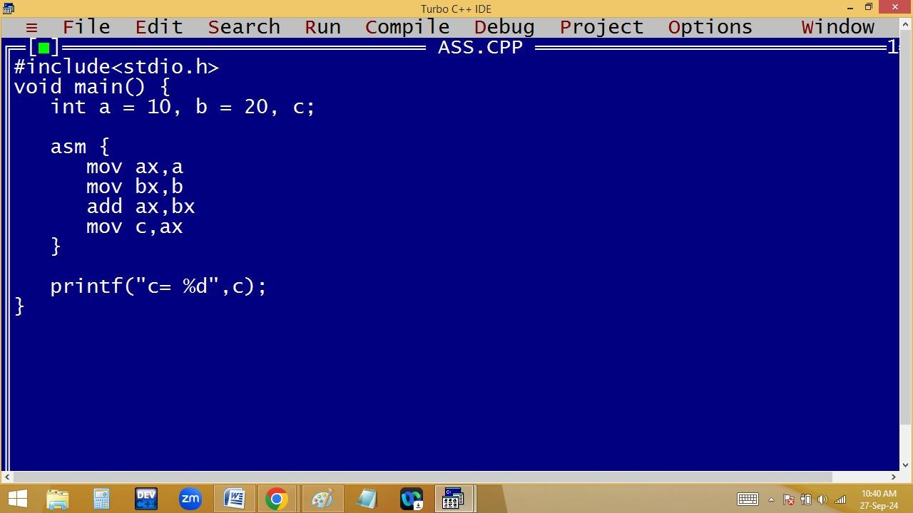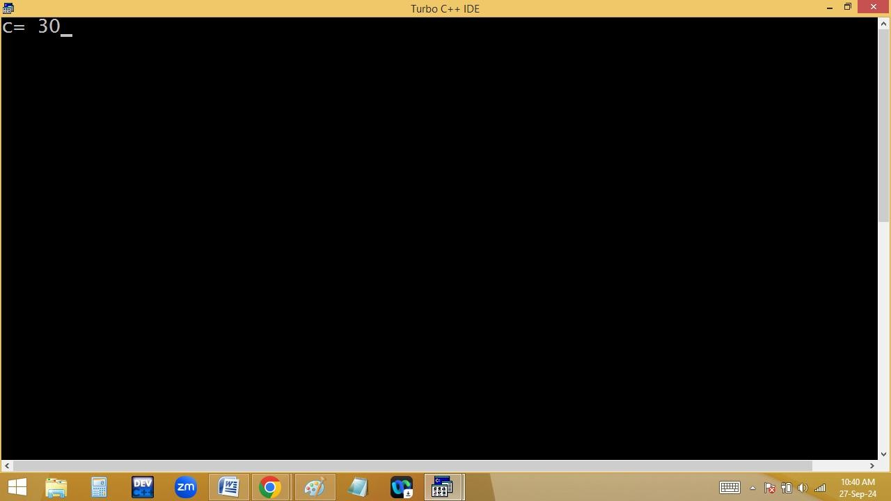

1. **High level language: Created with simple English and easy to understand.**

**Eg: good morning, please, subject,….**

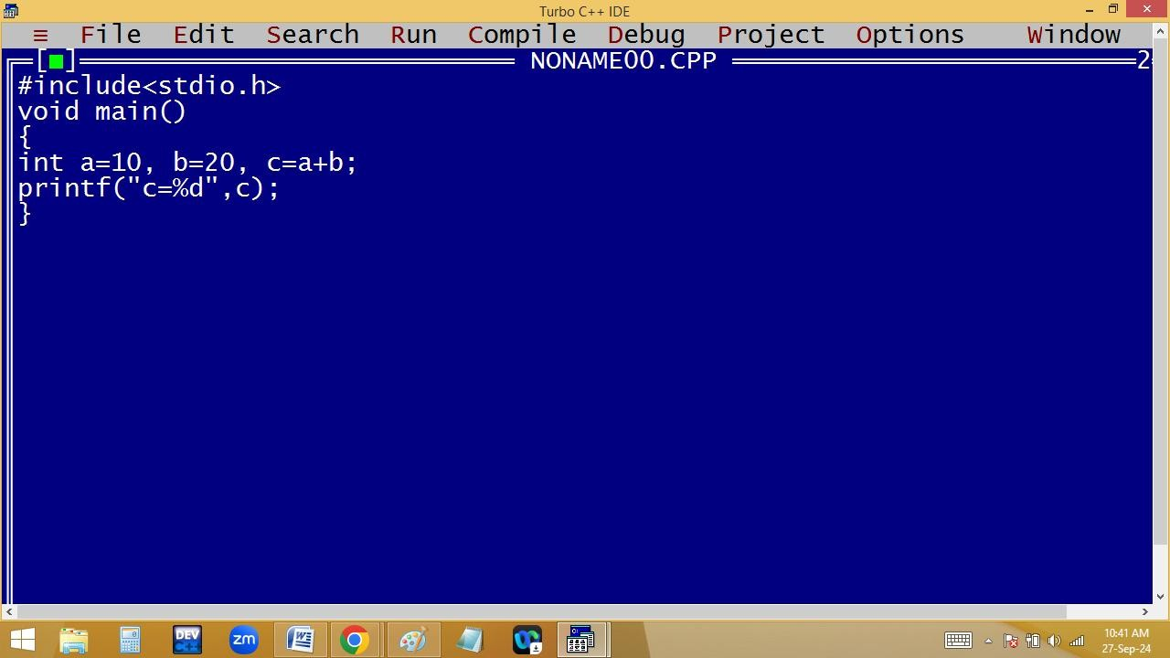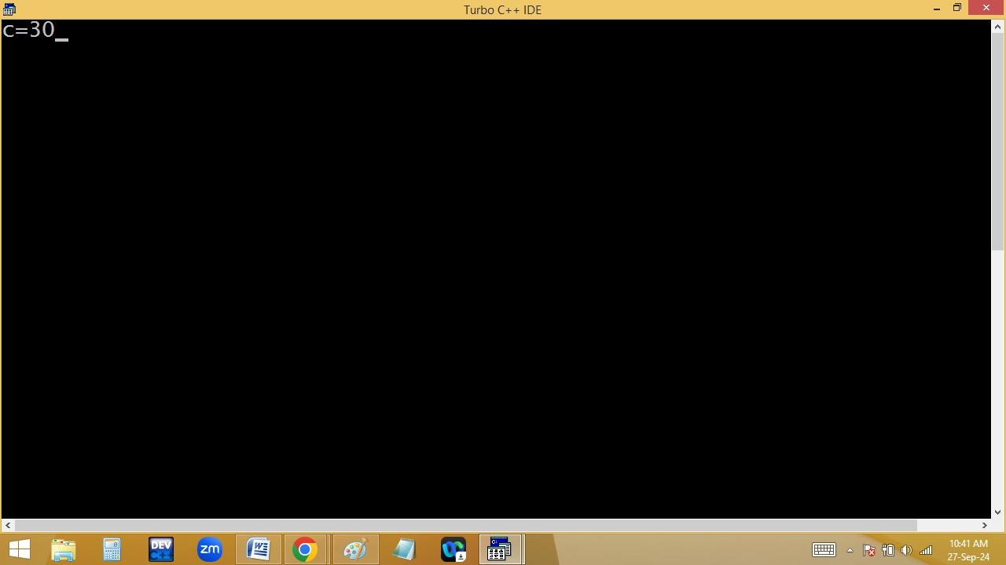

**C comes with both low level and high level features. Hence it is a middle level language. Because of both features using c we can develop system software and application software. Hence c is a multi-purpose programming language.**

**What is a compiler?**

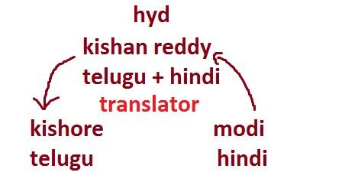

**Always the user given instructions are in English, which is called source code or so9urce program. But the machine understandable language is binary code / machine language. To convert the source code to binary code and to check the errors we are using the translators like Compiler / interpreter / assembler.**

**Compiler and interpreter both are used to convert high level programs to machine language [ binary code ]. Compiler converts the total program into binary code at once by leaving error lines.**

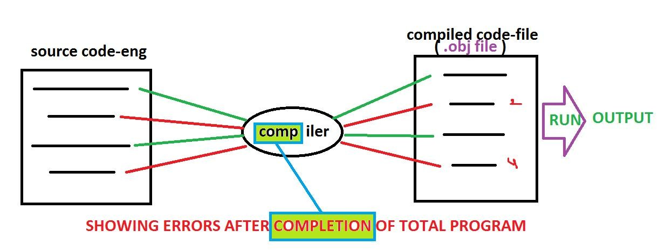

**Interpreter converts line by line.**

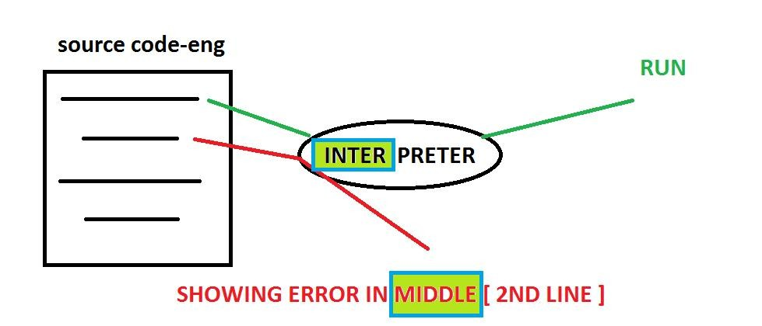

|  |
| --- |
| **low level programs to** |

**Assembler is used to convert**

**binary code.**

**Assembler working style is similar to the compiler.**

**In c language we are using compiler as a interpreter. Hence it is a compiler based programming language. In java we are using both compiler and interpreter. Hence it is a compiler based interpreted language.**

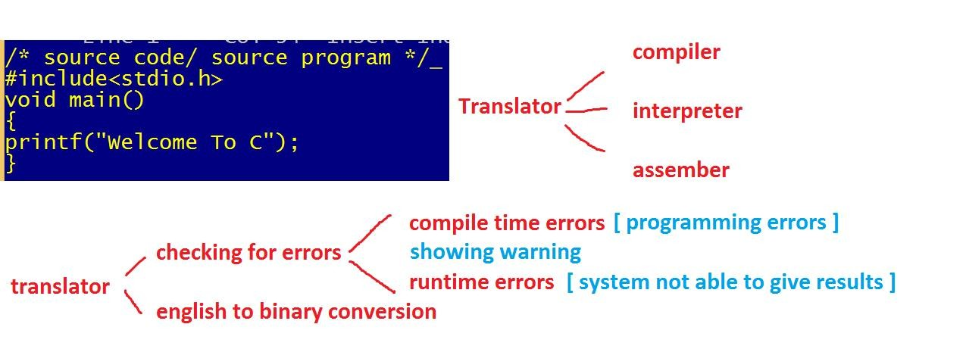

**Example for compile time error:**

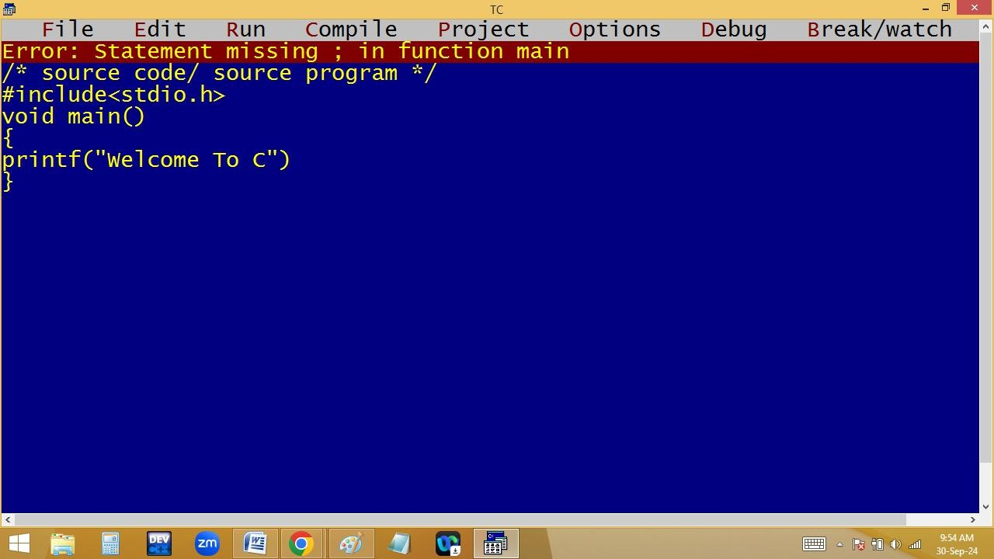

**Example for runtime error:**

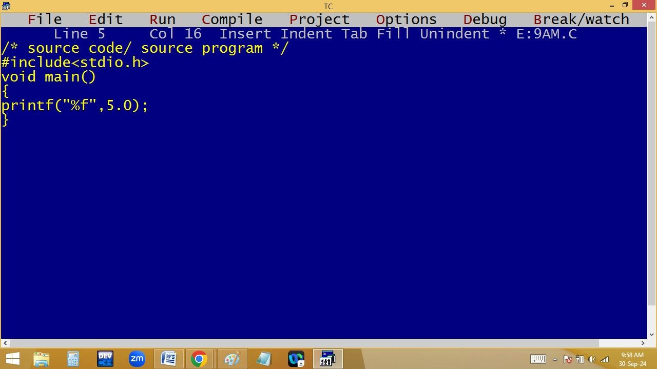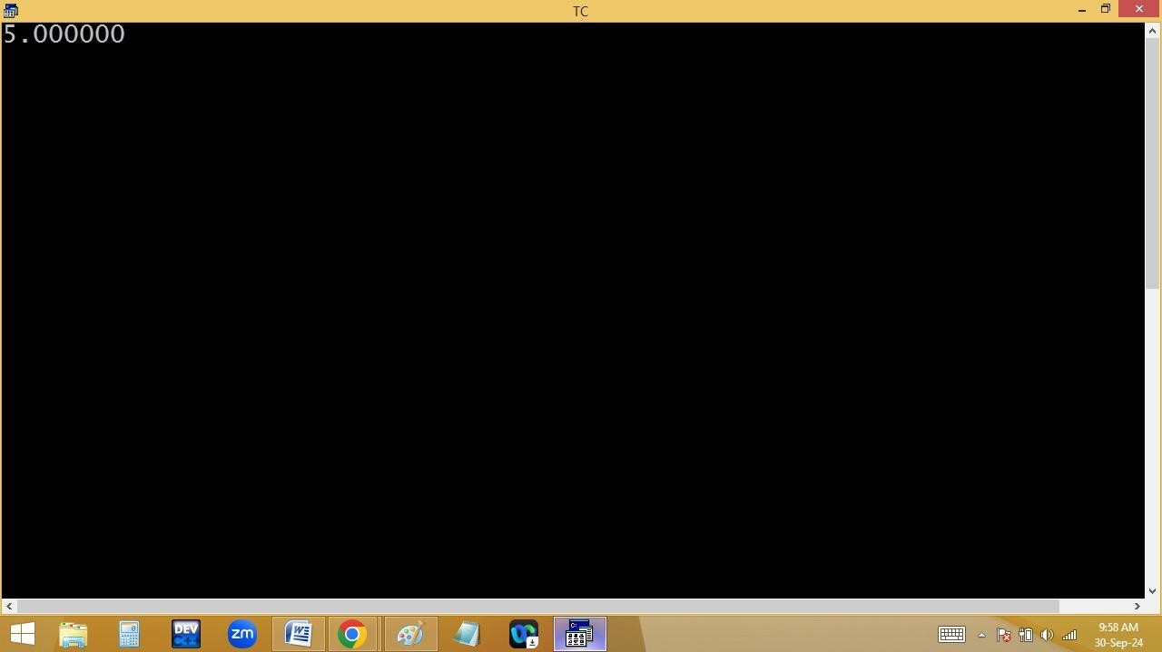

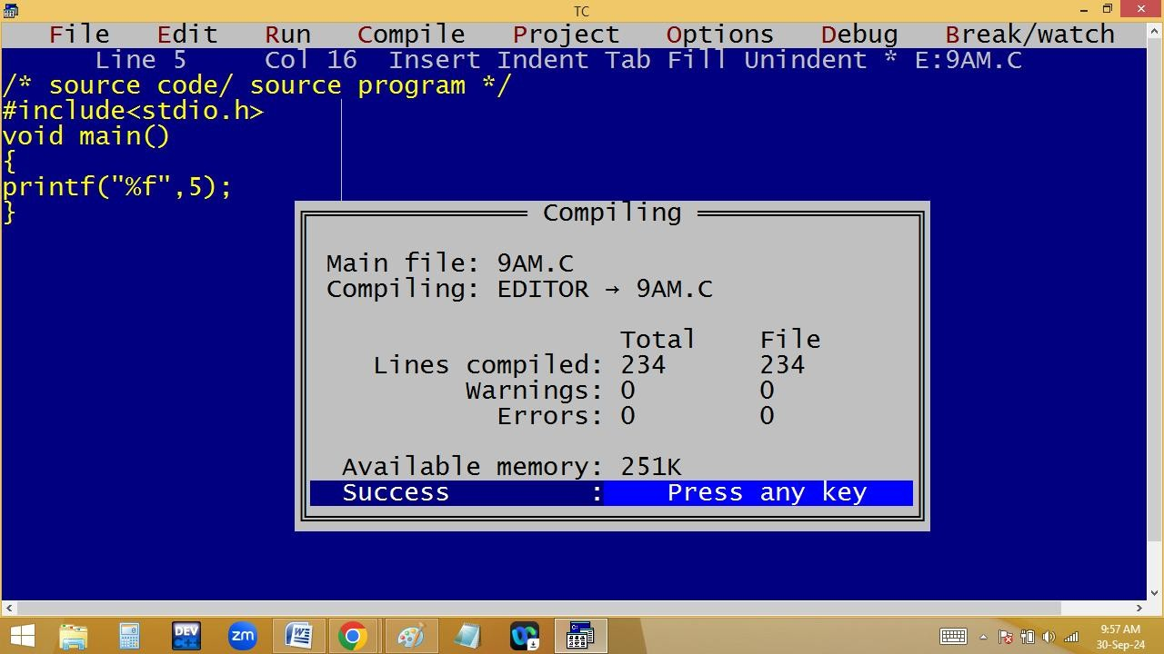

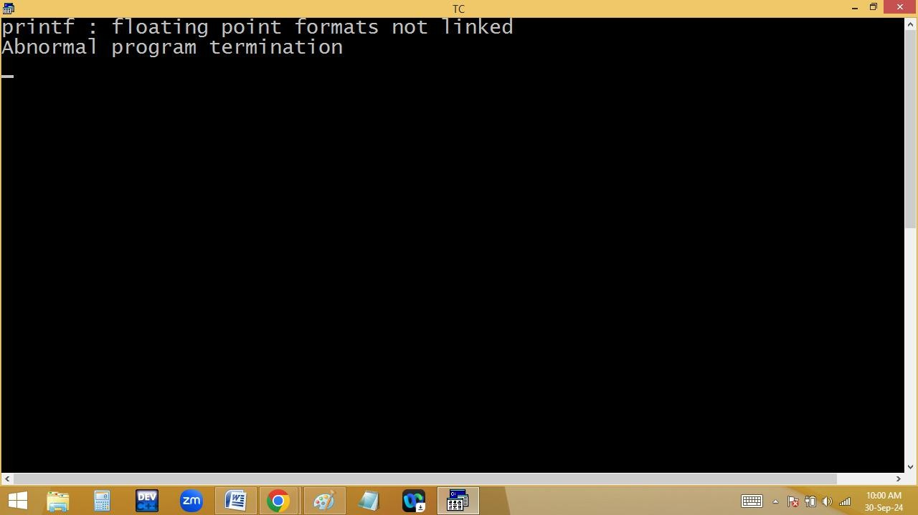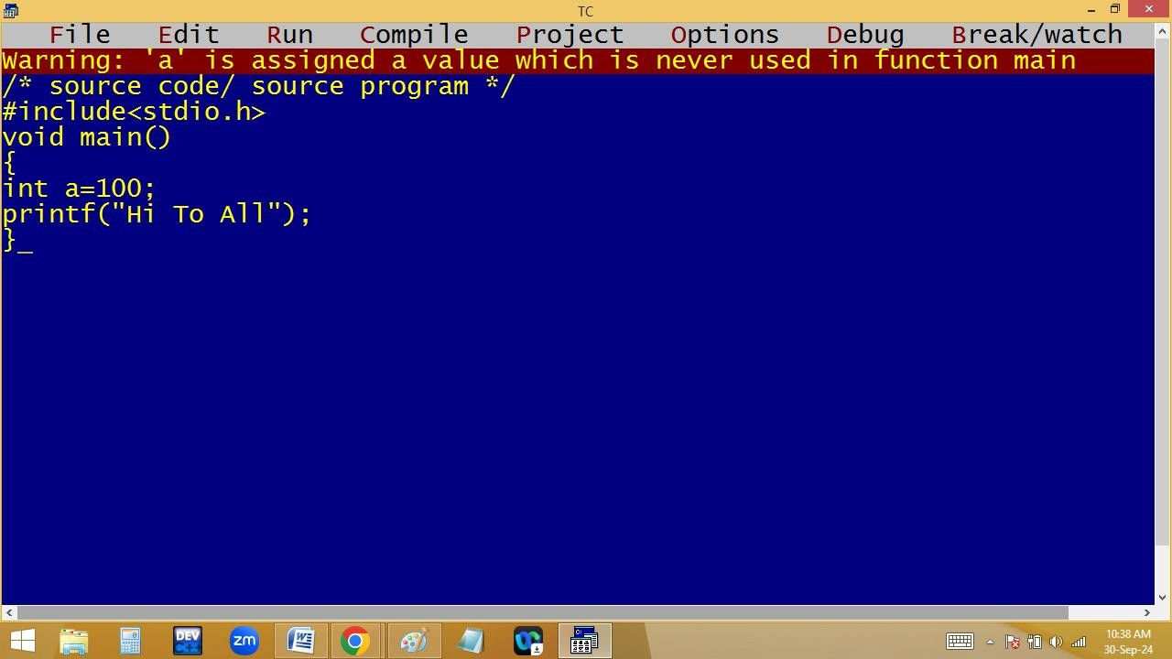

**What is called programming paradigm?**

**Every programming language comes with certain rules and regulations with a particular structure, which is technically called programming paradigm.**

**Before C language, the languages are using monolithic programming paradigm. Here the entire program they are creating by using a single program. Due to this it is very difficult to 1. Find the errors**

1. **Take more memory**
2. **Performance is low**
3. **No reusability**
4. **Program size increased**

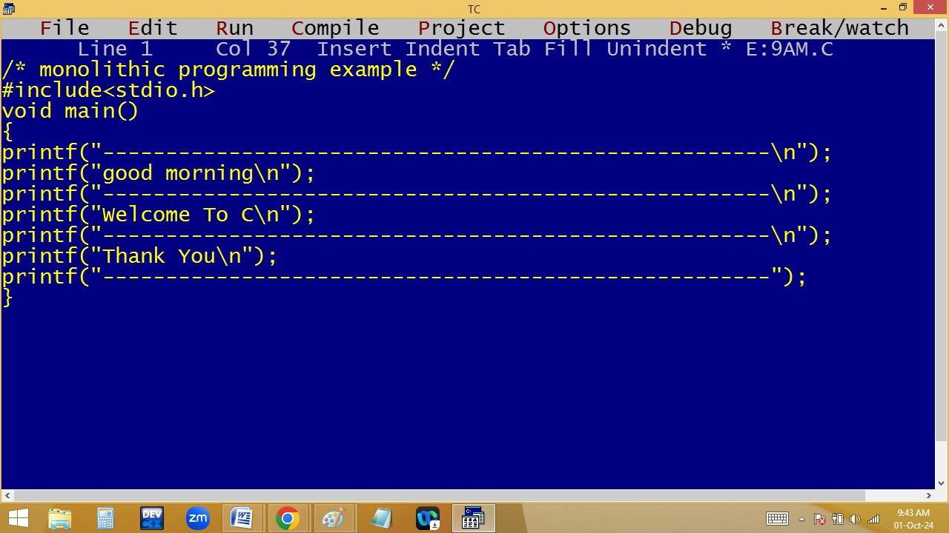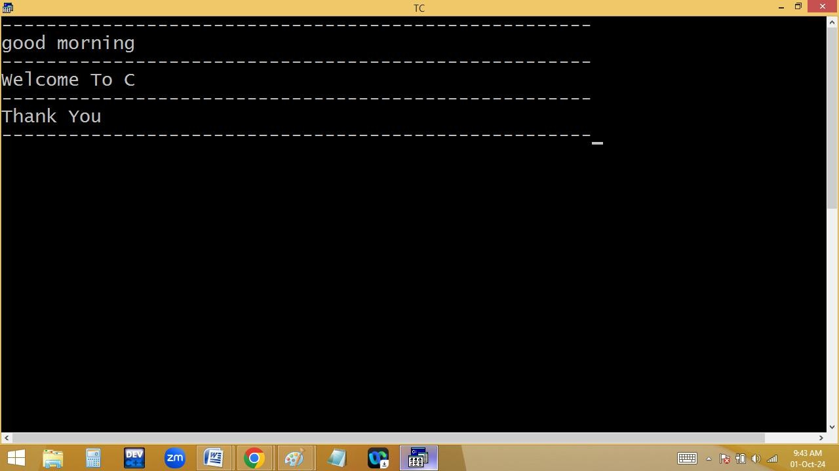

**What is procedure oriented programming structure[POP’s]: To avoid the drawbacks in monolithic programming problems, in C they have divided a big program into several small sub programs / sub routines / procedures / functions / modules / structures. i.e. C program is collection of procedures, it is called POP’s.**

|  |
| --- |
| **POP’s Advantages** |

**:**

1. **Modularity: Dividing big program into several small pieces as per the project requirement.**
2. **Simplicity: easy to read and understand.**
3. **Reusability: Write once, use many times.**
4. **Efficiency: Performance is high.**

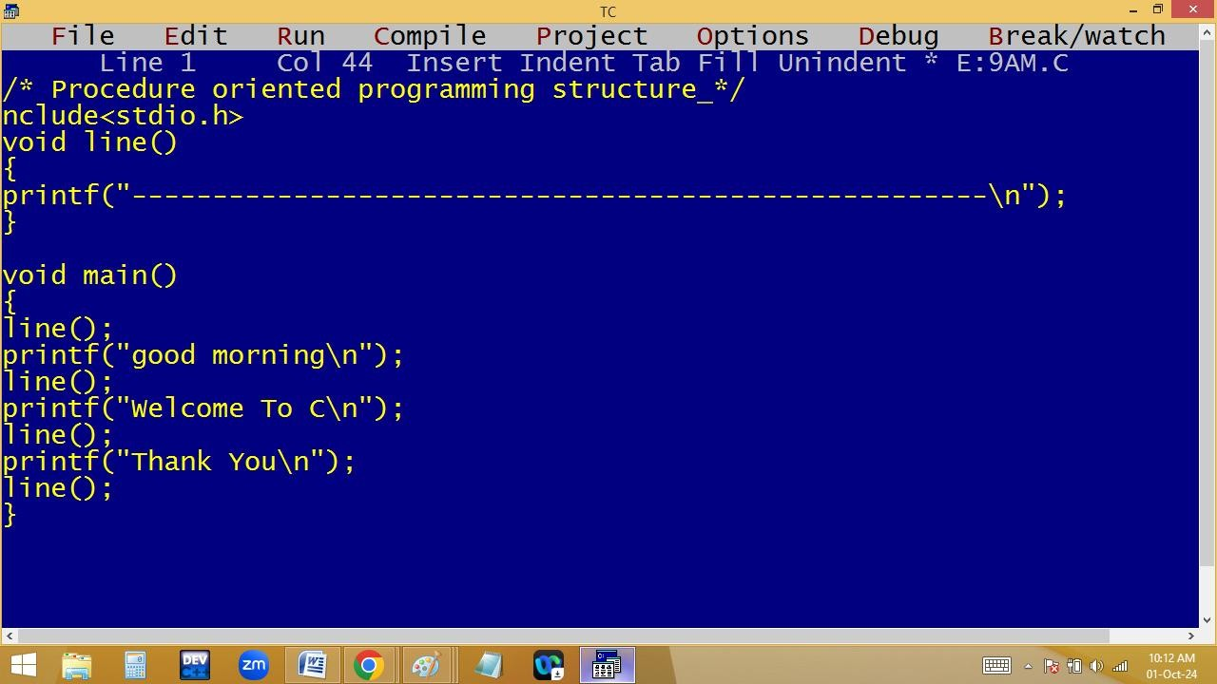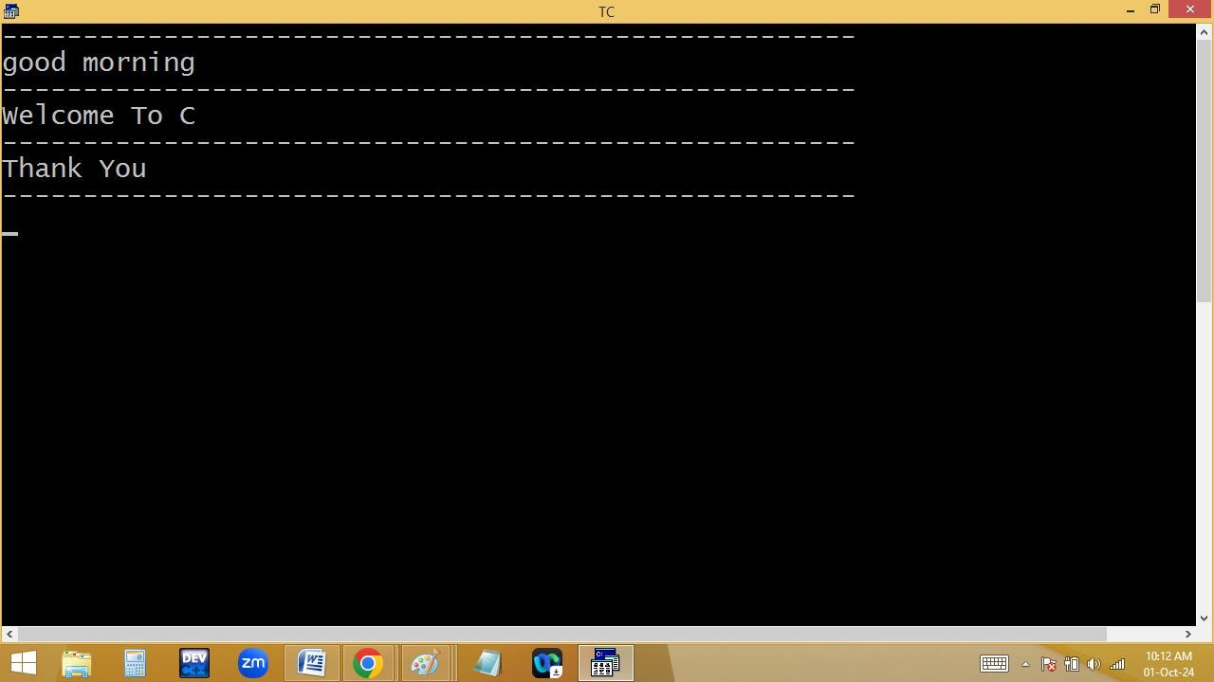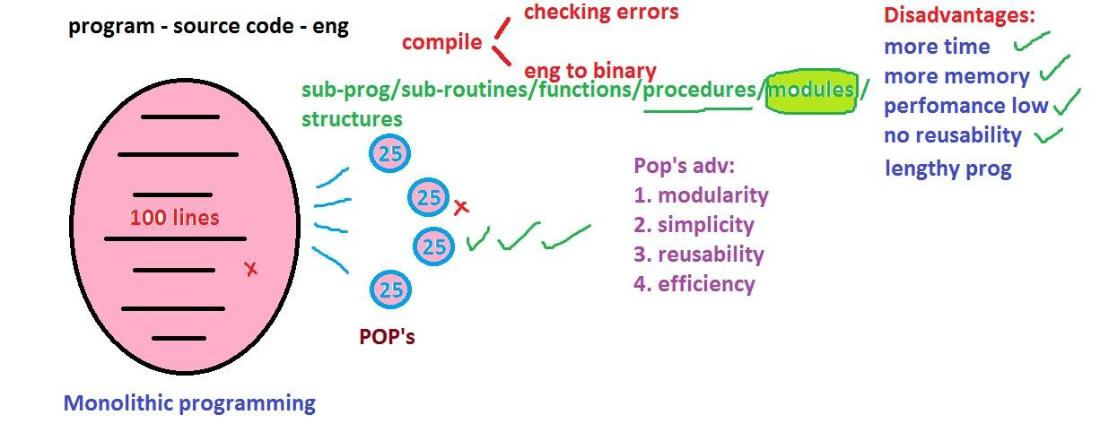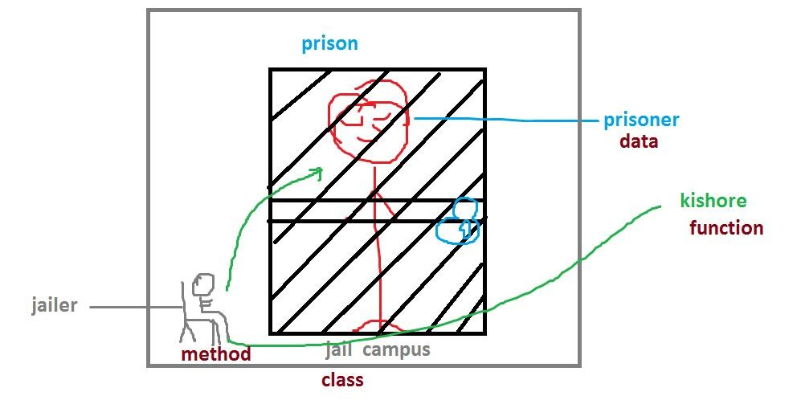

**POP’s Disadvantages:**

**In C the data is not secured because of by default it is public.**

|  |
| --- |
| **OOP’s** |

**:**

**Object Oriented Programming Structure**

**Features:**

* 1. **Class – It is a blue print to create the objects.**
  2. **Object: it is the physical instance/copy of class**
  3. **Data hiding – private / public / protected**
  4. **Encapsulation**
  5. **Inheritance**
  6. **Poly-many morphism-shapes / kinds / forms**
  7. **Abstraction - briefing**

**class father – programmer – super / base class**

**{**

**200 lines**

**2 crore building;**

**};**

**Class newclass create from oldclass / sub / derived class**

**{**

**200 lines;**

**Class child derived from father**

**{**

**2 crore building**

**}**

**Class stu**

**{**

**…;**

**…;**

**}**

**Class emp**

**{**

**…;**

**…;**

**}**

**Why c is a general purpose language?**

**Using c language we can develop the software like**

1. **Operating systems**

**Eg: windows, mac, unix, android, ios,….**

1. **Device drivers**

**Eg: audio / video / usb drivers,..**

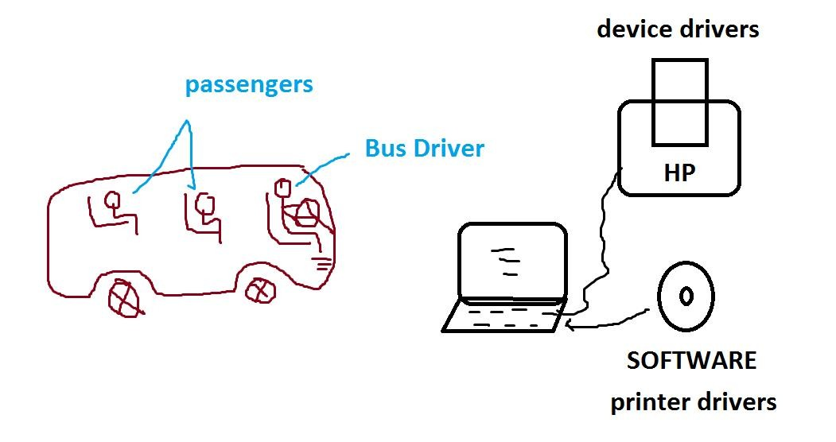

1. **Translators**

**Eg: compiler, interpreter, assembler**

1. **Commercial applications**

**Eg: hotel/ super market / college programs**

1. **Editors**

**Eg: Notepad, wordpad, ms-word,…**

1. **Data base**

**Eg: Oracle / SQL Server / My SQL / mongodb,…**

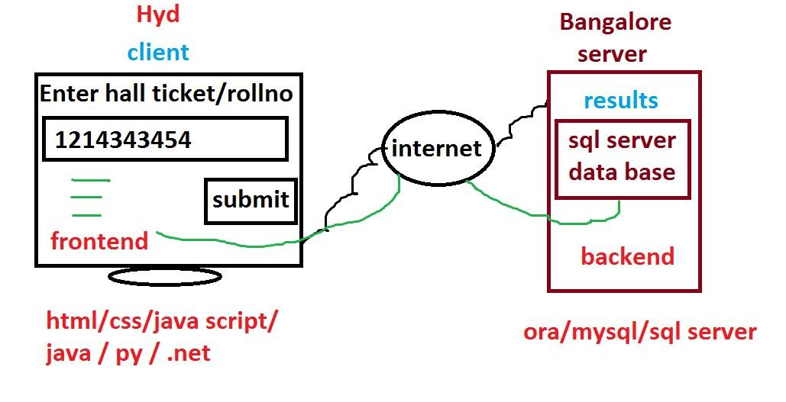

1. **Embedded applications Eg:**

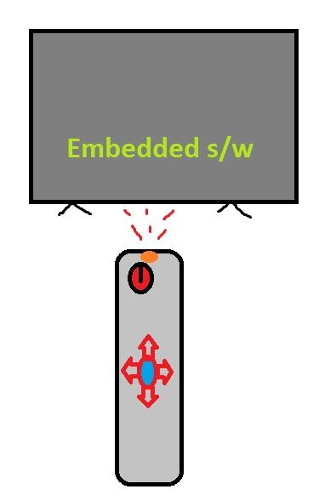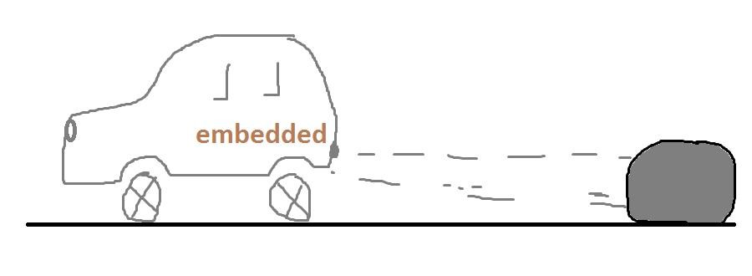

1. **Antivirus Eg: avast, norton, mcafee, nod,..**
2. **Browsers**

**Eg: chrome, firefox,…**

1. **Media players**

**Eg: vlc, mx-player, windows media player,…**

1. **PC & Mobile games**
2. **Any type of standalone applications**

**Hence c is also called it is a multi-purpose programming language.**

**HISTORY OF C**

**Basically C language introduced in 1972, by a software engineer named “DENNIS RITCHIE” working in AT & T [ American Telephone & Telegraph ] Bell labs, located at murray hills, new jersy, USA.**

**Ritchie adopted [ taken ] The compiler from B compiler / B Language, designed by “KEN THOMSON”, one of the software engineer in AT & T Bell labs.**

**Thomson adopted B language from BCPL [ Basic Combined Programming Language ], developed by an Assistant professor named “MARTIEN RICHARDS” in Cambridge University.**

**In 1989 ANSI [ American National Standards Institute ] released a new version of C language with the name “ANSI-C”, which is familiar with the name “C-89”.**

**In 1999 ISO [ International Standard Organization ] formerly known as IOS [ International Organization for standardization ] released a new version of c language with the “C-99”.**

**Basically C language designed for Rewriting UNIX operating system.**

**Nowadays we can create and execute a C program on any machine with any processor. i.e. we can execute the c programs on 80386 / 80486 / 80586 / intel core i3 / i5 / i7 / i9 / AMD Rayzon processors etc. Hence C is called it is a machine independent programming language.**

**For example the languages like 8086 / 8088 are working only on 8086 and 8088 processors. Hence they are called machine dependent programming languages.**

|  |
| --- |
| **platform dependent programming** |

**But C is alanguage.**

**i.e. the c applications designed for one operating system are not working in another type of operating systems. For example the C application designed for Window is not working in UNIX or Linux etc. Due to this problem, using C language we can’t design web applications. C is a machine independent but platform dependent, it is also called partial portable language. Because of this problem by using C we can develop only the standalone applications.**

**Standalone applications installed in a single system and operated from that system only.**

**The languages like Java / .Net / Python are platform independent and machine independent. Hence they are called portable languages and they are used to develop both web applications and standalone applications.**

**Web applications are installed in a web server and access across the world by using the web clients.**

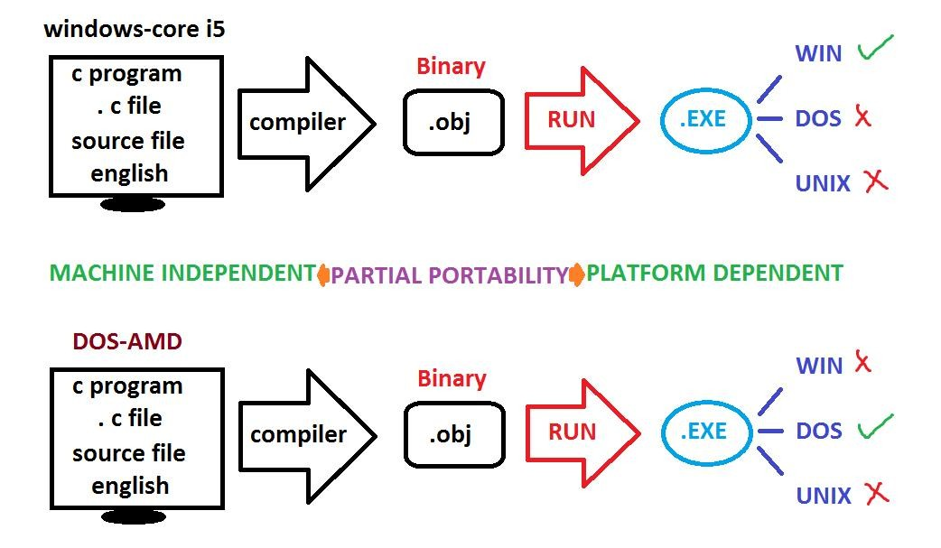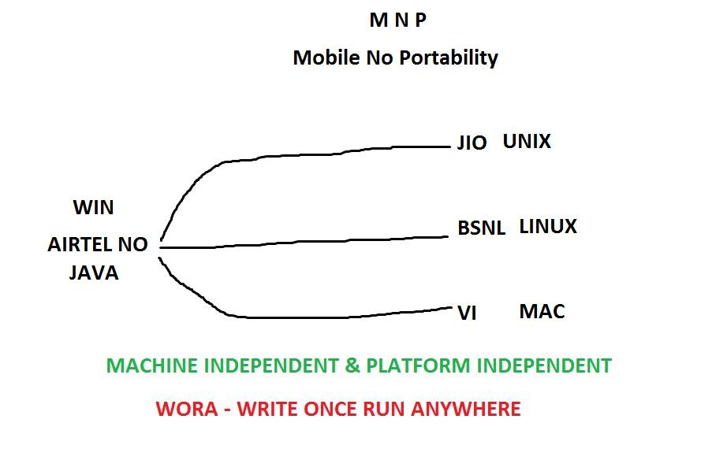

**FUNDAMENTALS OF C**

|  |
| --- |
| **C CHARACTER SET** |

**: Every programming language having**

|  |  |
| --- | --- |
| **CHARACTERS** | **ASCII VALUES** |
| **a-z** | **97-122** |
| **A-Z** | **65-90** |
| **0-9** | **48-57** |
| **Space** | **32** |
| **Back space** | **8** |
| **Tab key** | **9** |
| **Enter** | **10** |

**a particular character set and by using this character set only we can make the programs [ software ]. C uses ASCII character set, which comes with 256 characters. In this we are having 52 alphabets [ a-z, A-Z ], 10 digits [09], 44 operators[ +,-, *,… ], 14 separators [ , . : ; “ “ ‘ ‘ ( ),..] and remaining all are special charaters.**

|  |  |
| --- | --- |
| **English language** | **C language** |
| **26 alphabets** | **ASCII characters-256** |
| **English words** | **C keywords - 32** |
| **English sentences** | **Instructions** |
| **English paragraphs** | **Programs** |
| **English documents** | **Software** |
| **Esc** | **27** |
| **\*** | **42** |
| **+** | **43** |

**ASCII – American Standard Code for Information**

|  |  |
| --- | --- |
| **IBM** | **Corporation** |

**Interchange – 256 characters –**

**[ International Business Machines ] American company**

|  |
| --- |
| **Universal code** |

**Java / Py / .Net – Unicode Characters –-**

**65536 characters**

**C-TOKENS**

**The smallest individual words we are using in developing a c program are called C-tokens. They are of different types.**

**1.Keywords: The system predefined / reserved words are called keywords. Each keyword is having certain meaning and as a user we can’t change this meaning.**

**C comes with 32 keywords.**

**Eg: auto, break, continue, char, case, const, do, default, double, enum, else, extern, float, for, goto, int, long, while, switch, short, unsigned, union,…**